**CloudWatch Dashboard Assingment**

**(Shreyas Bhinge)**

**Problem Statement:**

**You work for XYZ Corporation. To maintain the security of the AWS account and**

**the resources you have been asked to implement a solution that can help easily**

**recognize and monitor the different users. Also, you will be monitoring the**

**machines created by these users for any errors or misconfigurations.**

**Tasks To Be Performed:**

**1. Create a dashboard which lets you check the CPU utilization and**

**networking for a particular EC2 instance.**

Step 1: Create a instance

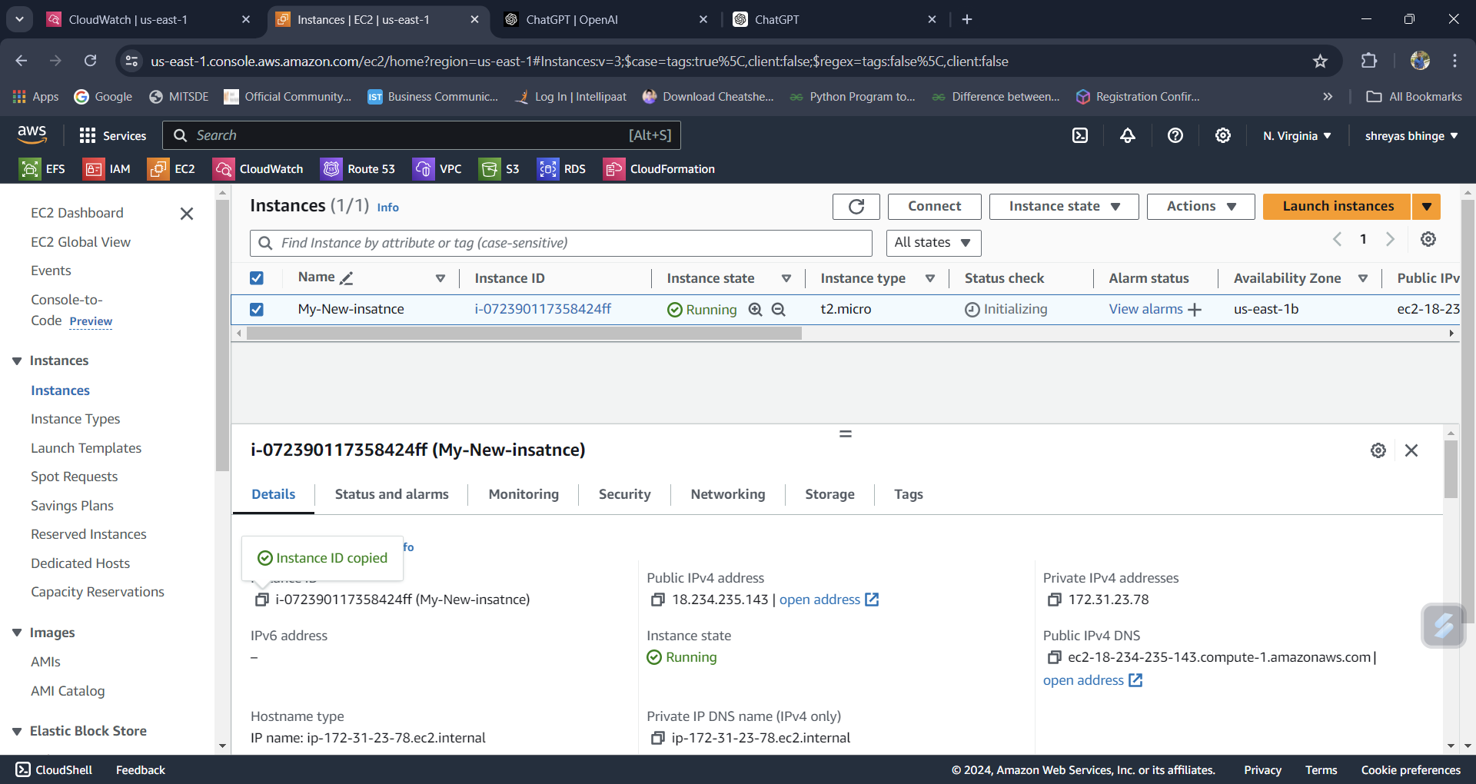

Step 2: Set Up CloudWatch Alarms

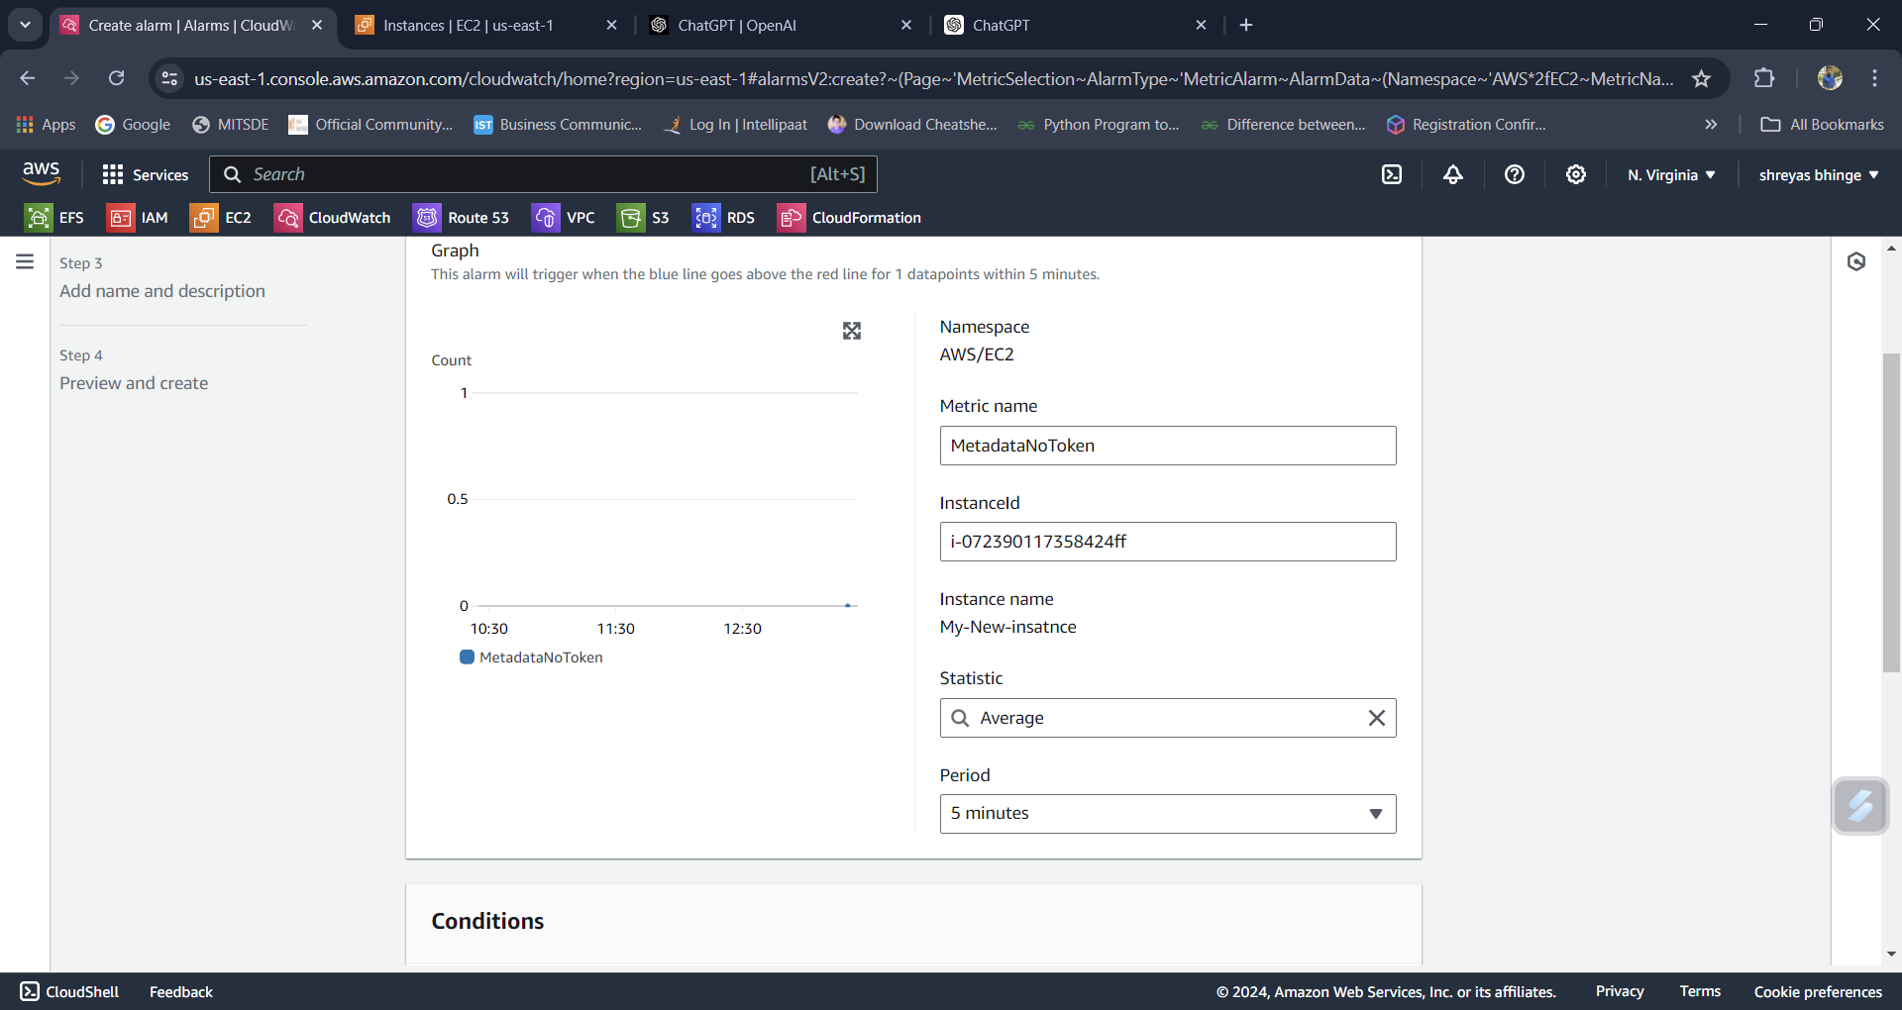

1. Create Alarms for CPU Utilization:

* Navigate to Alarms on the left-hand menu.
* Click on Create Alarm.
* Click Select metric and choose EC2 > Per-Instance Metrics.
* Select your instance and then select CPUUtilization.
* Click Select metric.
* Set the conditions for the alarm, e.g., if CPU utilization is greater than 50%.
* Configure actions (optional), such as sending a notification via SNS.
* Name the alarm and create it.

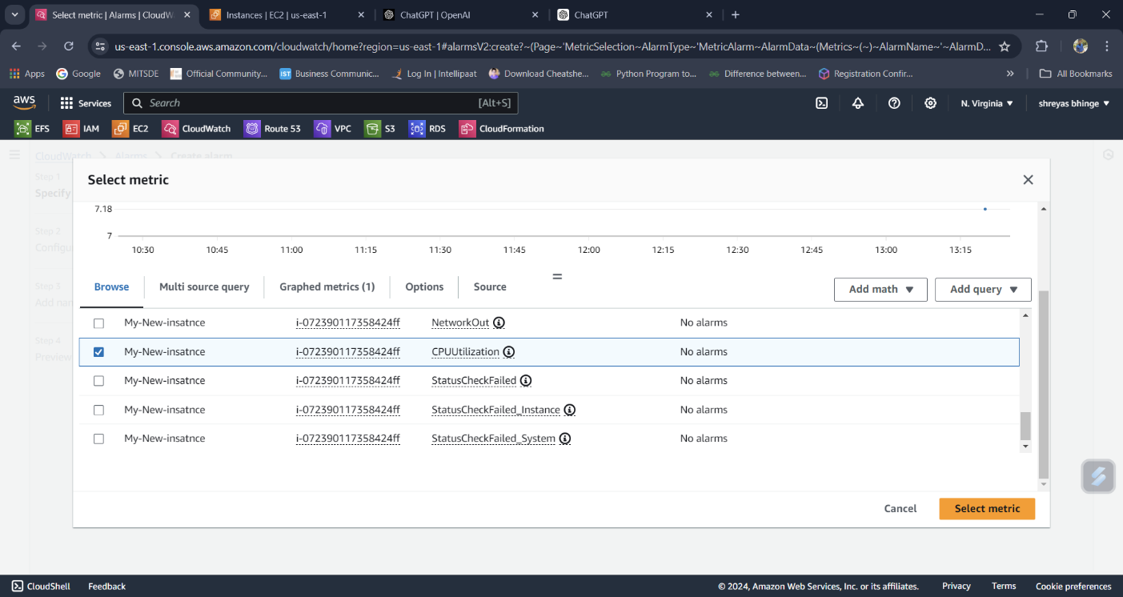

1. Create Alarms for Networking:

* Repeat the above steps but select networking metrics like NetworkIn and NetworkOut.

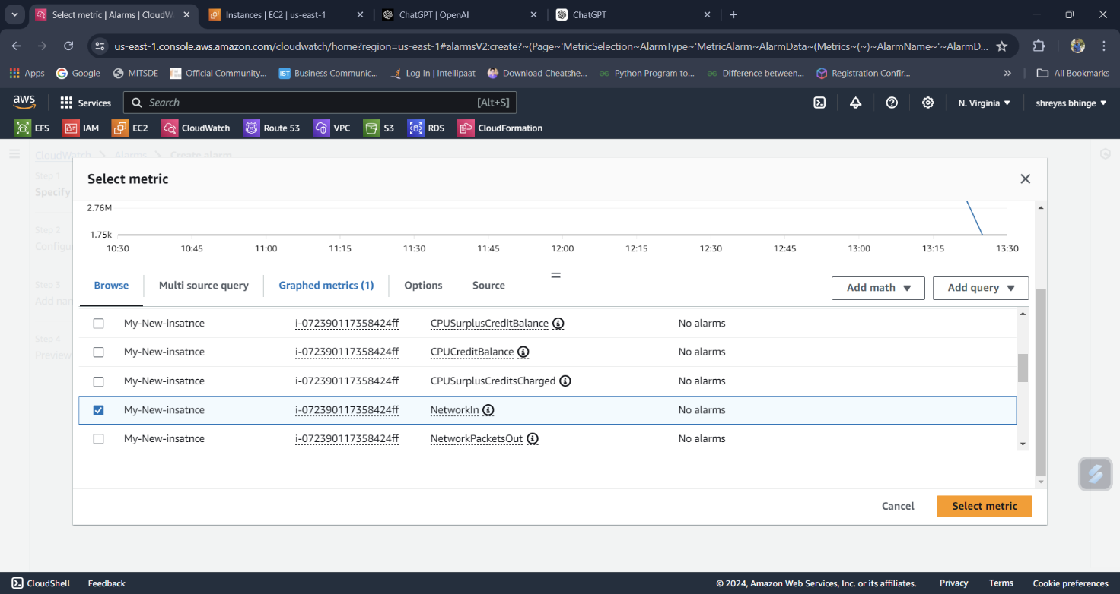

Step 2: Create a CloudWatch Dashboard

* Navigate to Dashboards: In the CloudWatch console, click on Dashboards in the left-hand menu.
* Create a New Dashboard:
* Click Create dashboard.
* Enter a name for your dashboard.
* Choose the type of widget you want to add (e.g., line graph, number, text).
* Add CPU Utilization Widget:
* Click Add widget.
* Select Line.
* In the metrics browser, choose EC2 > Per-Instance Metrics > CPUUtilization.
* Select your instance and click Create widget.
* Add Networking Widgets:
* Repeat the above steps to add widgets for NetworkIn and NetworkOut.

